Module – 4 (C++ & OOPS)

1. Write a program of Fibonacci and factorial using Class.

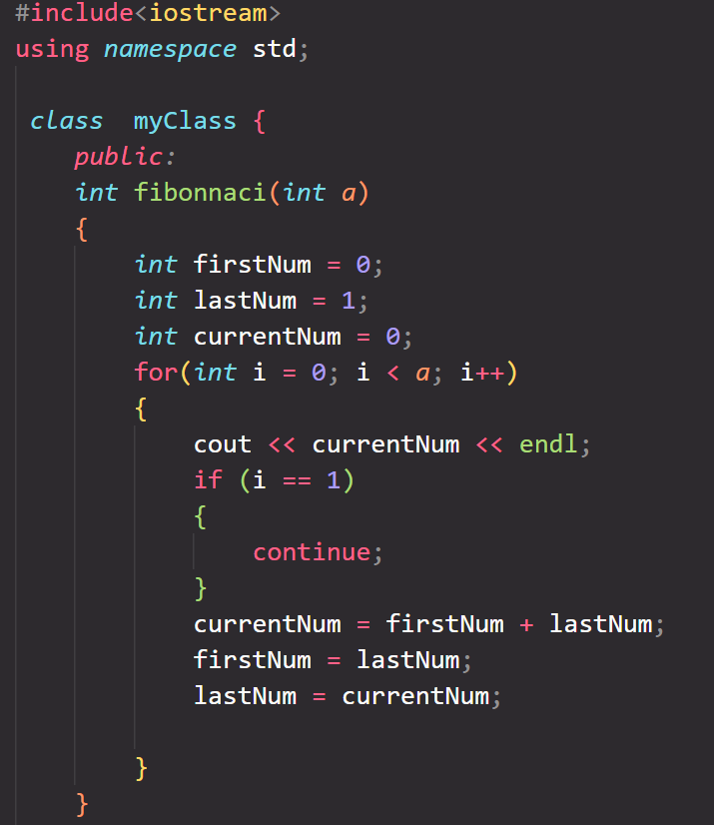 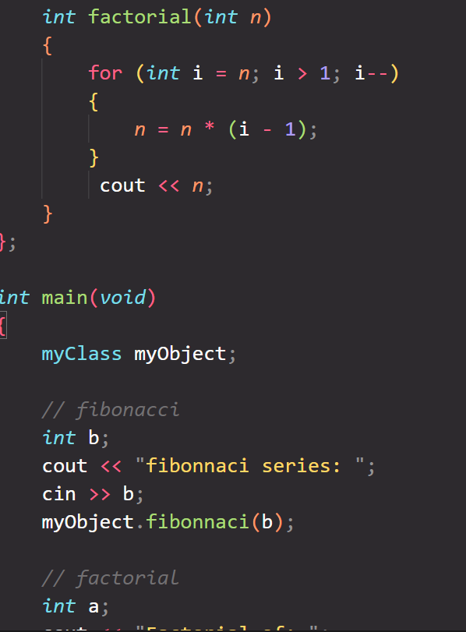

1. Write a program to Addition, Subtraction, Multiplication and Division of two numbers using Class.

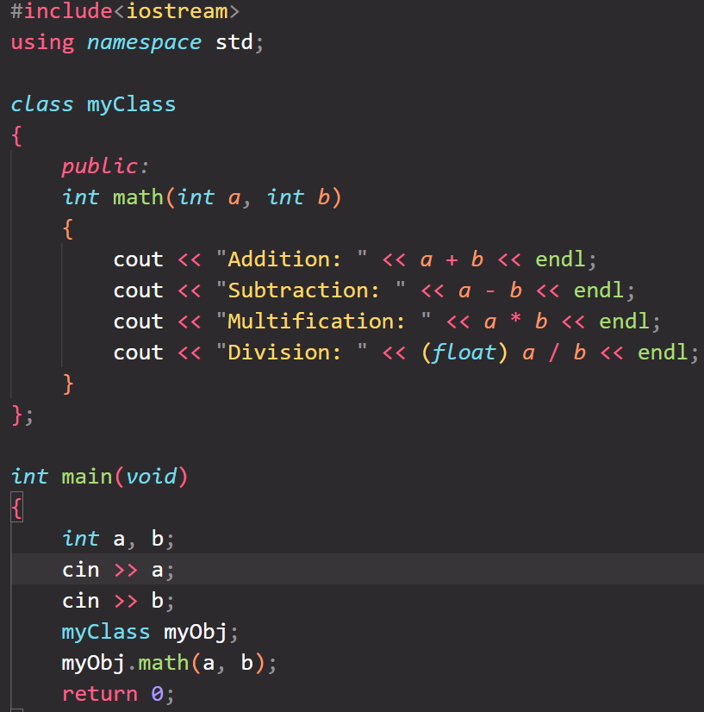

1. Write a program of to display a matrix using class.

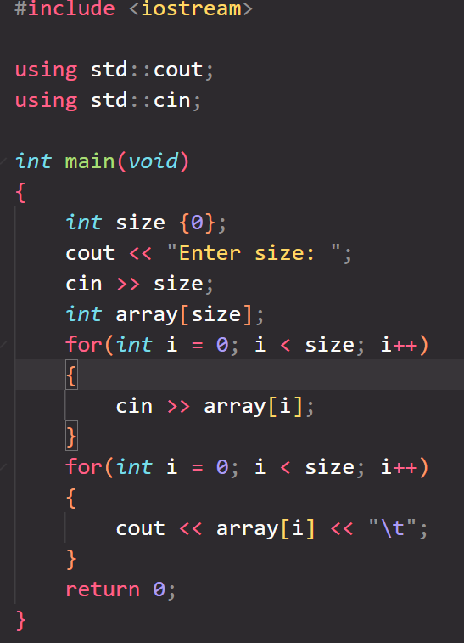

4.Write a program of Addition of two Matrix using Class.

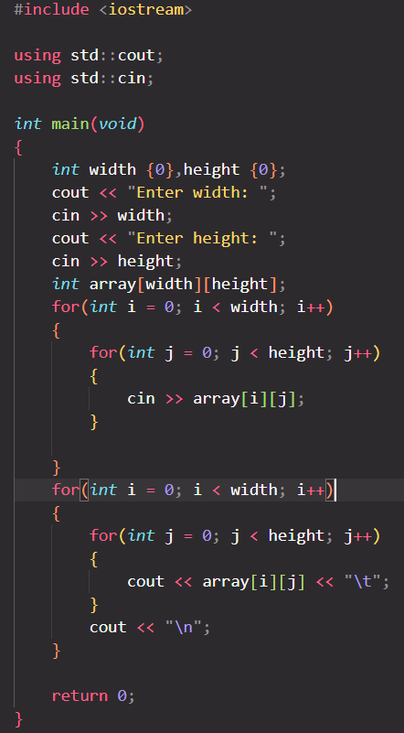

5. Define a class to represent a bank account. Include the following members Data

Name of the depositor, Account Number, Type of Account, Balance amount in the account Member Functions, to assign values, to deposited an amount, to withdraw an amount after checking balance, to display name and balance

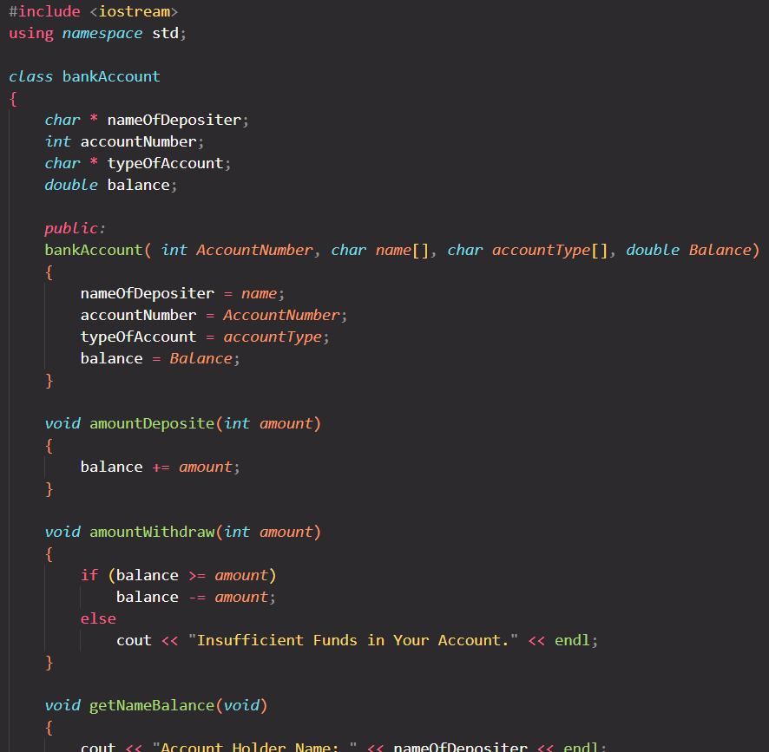

6. Define a class to represent a book shop Include the following members Data

Name of Author, Name of Title, Name of Price, Name Publisher, Member Functions -To Assign Values -To Display Values

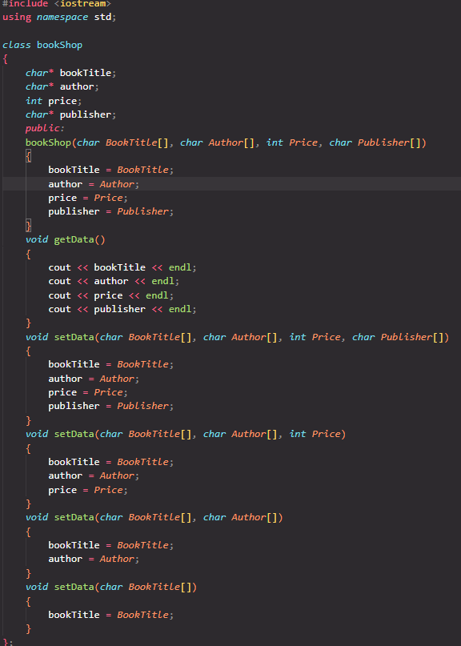

8. Define a class to represent lecture details. Include the following members and the program should handle at least details of 5 lecturer.

Name of the lecturer, Name of the subject, Name of course, Number of lecturers

9. Write a program of to display in this format using class.

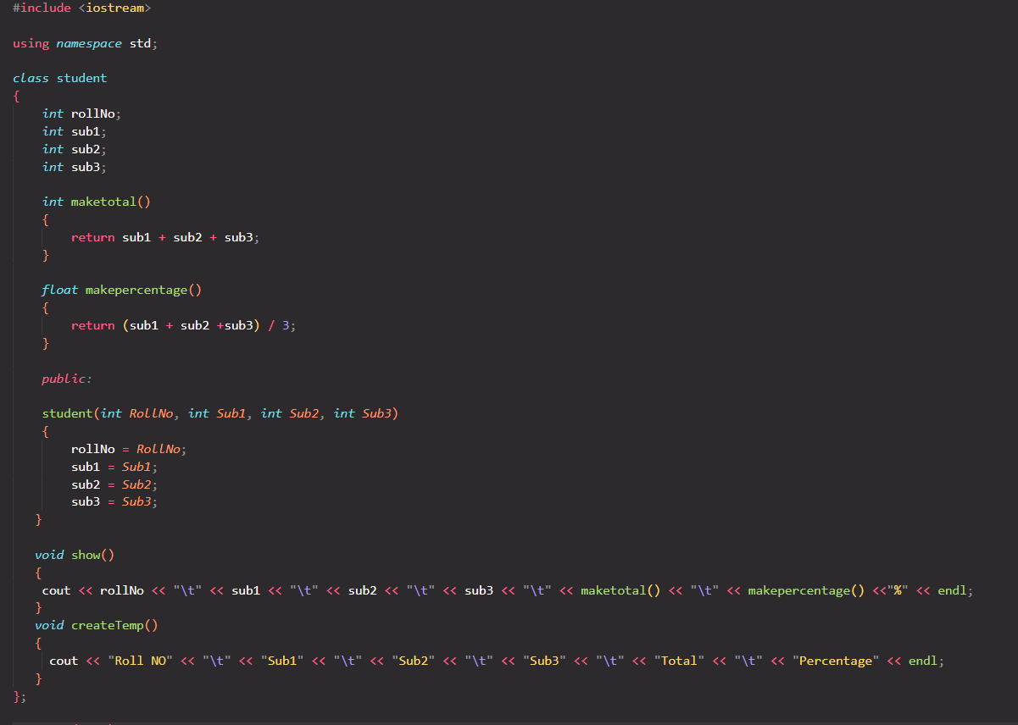

10. Write a program of Addition, Subtraction, Division, Multiplication using constructor.

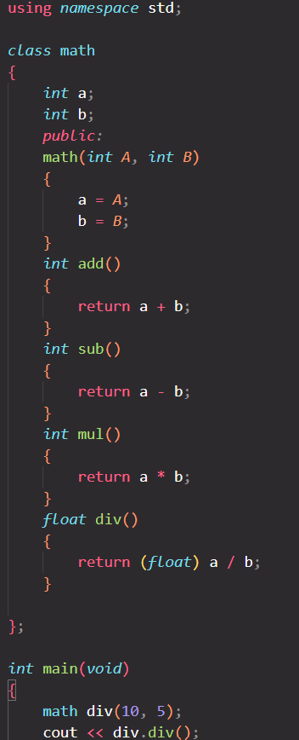

11. Write a program of find the simple interest using constructor with dynamic initialization.

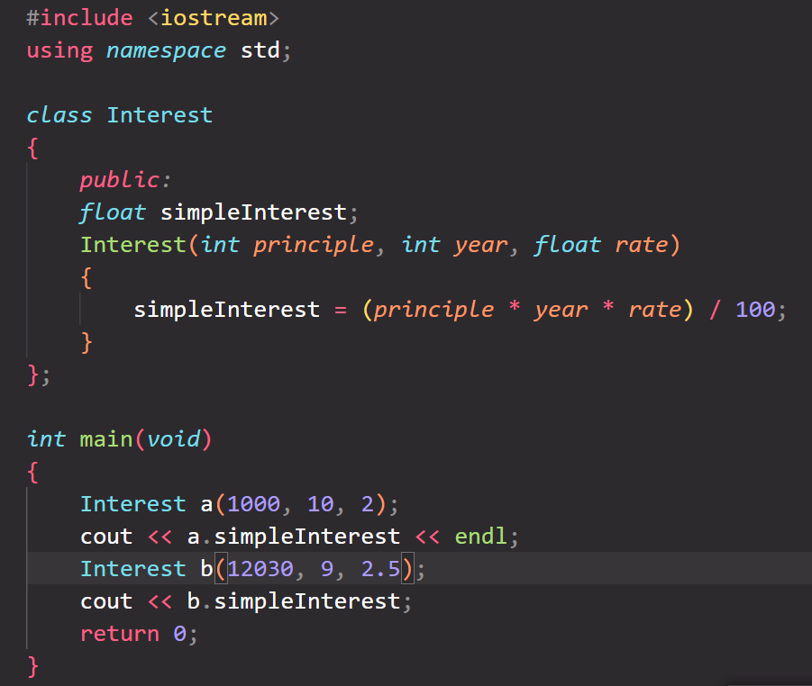

12.Write a program to calculate the area of circle, rectangle and triangle using Function Overloading

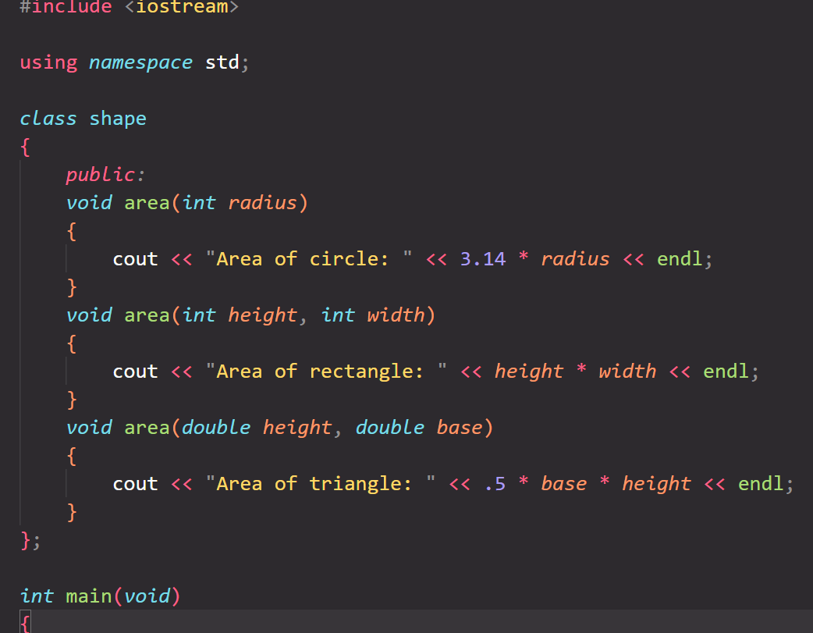

13.Write a program to find the multiplication values and the cubic values using inline function.

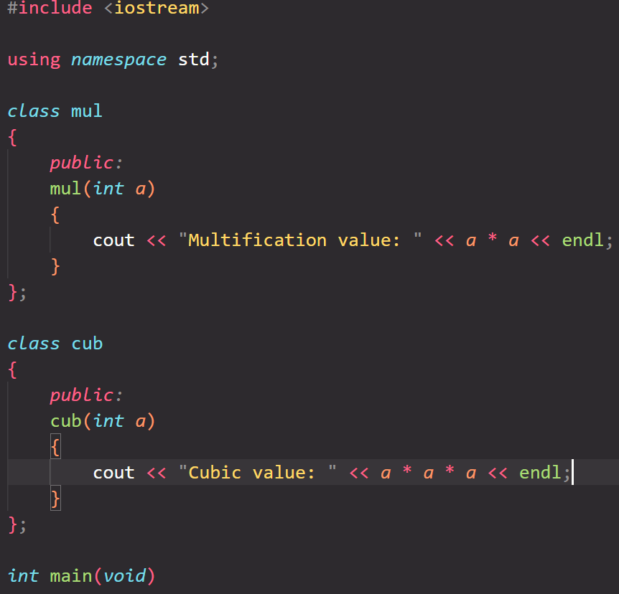

14. Write a program to Mathematic operation like Addition, Subtraction, Multiplication, Division Of two number using different parameters and Function Overloading.

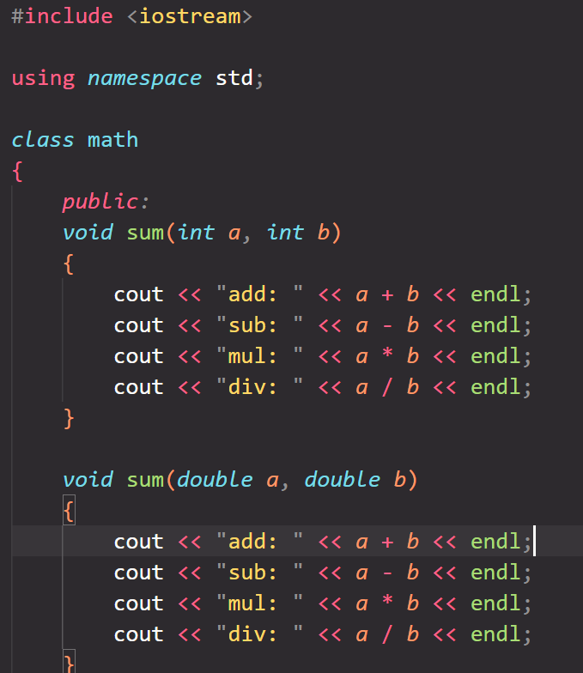

15.Write a Program of Two 1D Matrix Addition using Operator Overloading

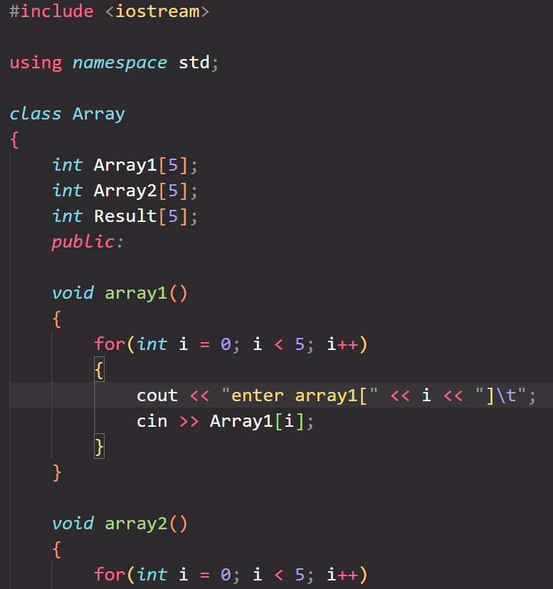

16.Write a program of concatenate the two strings using Operator Overloading

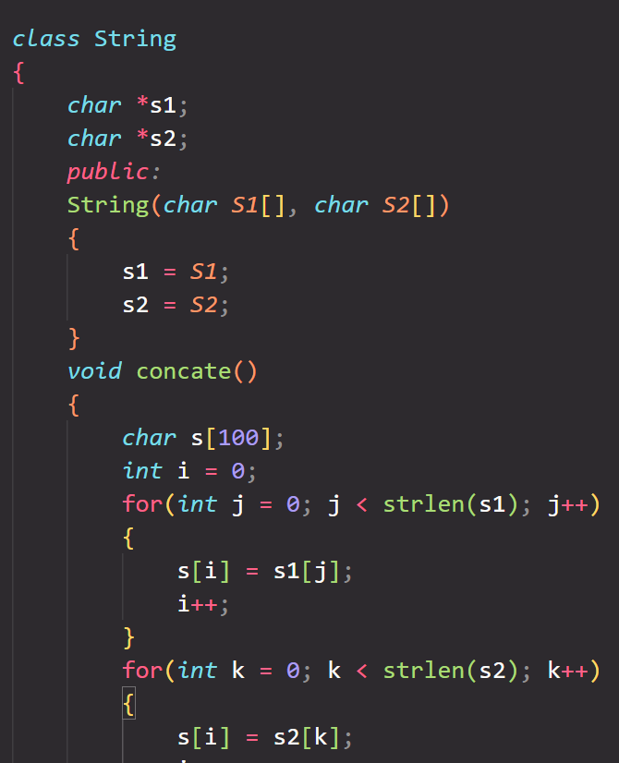

17.Write a program of Addition, subtraction and multiplication of two numbers using Binary Operator overloading with switch case

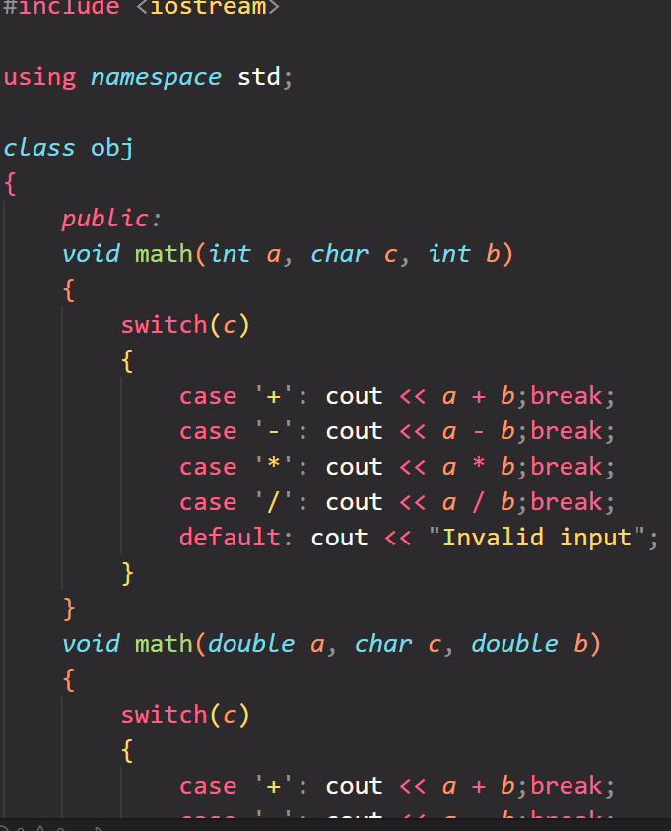

18. Assume a class cricketer is declared. Declare a derived class batsman from cricketer Data member of batsman. Total runs, Average runs and best performance. Member functions input data, calculate average runs, Display data. (Single Inheritance)

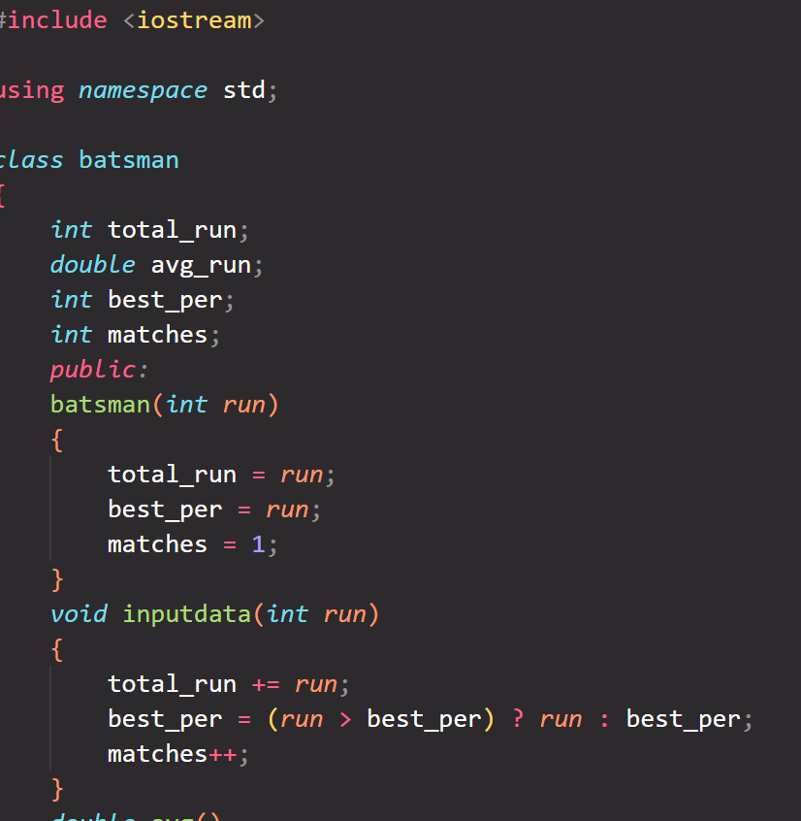

19. Create a class person having members name and age. Derive a class student having member percentage. Derive another class teacher having member salary. Write necessary member function to initialize, read and write data. Write also Main function (Multiple Inheritance)